It Is Easy To Save Money at TOURISM. LEISURE. HOTELS 2019
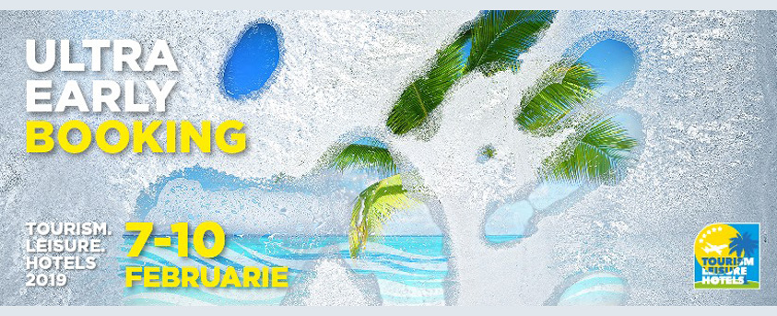
Any trip should be carefully planned, well in advance, taking in consideration all the details. Experienced travelers choose early booking as a way to save money and arrange guaranteed holidays on their chosen dates. And right now the early booking season is in full swing. But do not rush to order a tour right now, because there is an opportunity to get the same for even less money. How? Take advantage of ultra-early booking offers at TOURISM. LEISURE. HOTELS 2019, held from February 7 to 10 at Moldexpo.

Organizer: International Exhibition Centre Moldexpo SA
Co-organizer: Moldova's Investments Agency
Partners:
- Association of Employers of the Tourism Industry APIT
- Association for Development of Tourism in Moldova ADTM

Come, choose and buy on the spot
From February 7 to 10, more than 70 travel companies from Moldova, Turkey, Romania, Bulgaria, Ukraine, Hungary, Spain and India will submit ultra-early booking offers to almost all existing destinations. Additional discounts on early booking offers will be available only at TOURISM. LEISURE. HOTELS 2019.The exhibitors will present both traditional beach destinations, as well as new tourist packages, packages for different categories of tourists, various family vacation options in summer and in the velvet season, a wide selection of spa resorts, excursions and much more. Like, for instance, a colorful vacation in Egypt with Join Up Moldova, special prices for holidays in Hungary from Fabrica-Tur, stunning discounts in all directions from Voiaj International, direct flights from Chisinau to Bodrum and Izmir from Tez Tour Moldova, discounts for holidays in Kusadasi and Marmaris from Ozege Travel and more.

Guest country of the exhibition - Bulgaria
More than 15 representatives of the tourism industry in Bulgaria will present the tourist destinations of this year. There will be super offers for holidays in Albena, Golden Sands, Sunny Beach, Nessebar, Burgas, St. Constantine and Elena, Sozopol. Bulgarian hoteliers will also offer their special offers. And on February 9, the exhibition will host the Day of Bulgaria. After all, Bulgaria is not only sea and beaches, but also original cuisine, archaeological tours, water tourism, spa tours, bicycle tours, various festivals. This is a great opportunity to get acquainted with the whole diversity of the country's culture and to discover a new direction for recreation – health-restoring recreation.
Romania from A to Z
Romania is the territory of medieval castles, Gothic cathedrals, ancient cities, national parks, magnificent seaside resorts and health centers. The country has everything for a wonderful vacation, while the cost will fill with joy even the most economical travelers. More than 20 representatives of the leisure sector of Romania will provide the most detailed information on how best to plan a vacation in this country.There will be a wide range of proposals for therapeutic and recreational vacations, including springs in Baile-Olanesti and the solar thermal lake in Sovata. And, of course, ecotourism, popular in recent years, in Romanian villages, as well as a varied program of excursions to the historical sights of Romania. Comfortable vacations for small money, opportunities for diving and other water sports, boat trips, holidays with children, 125 own excursion routes - Paralela 45, one of the country's most famous tour operators, uniting 45 Romanian agencies and 1 agency from the Republic of Moldova, will tell you about this and about many other things.

All destinations are available!
Quality wellness sojourns at Truskavets - the best balneological resort in Western Ukraine - will be presented by Hotel Management Group. There is a hotel and recreation complex of premium class Mirotel Resort & Spa, Villa “Christina” of de-luxe class and a renovated hotel “Spring 3 *”, as well as the medical-diagnostic center Med-Palace Spa Center. Tempting offers of beach, health and sightseeing vacations will be presented by 3 more companies from Ukraine.
At the exhibition, you can get to know the famous balneological resort Hajdúszoboszló (Hungary). Hajdúszoboszló is not just a health resort, but a well-known area of ​​cultural tourism, as well as a water park, aqua palace, themed pools and an ice cave bath.
Relax in the themed hotels, visit the fantastic parks on the Mediterranean coast, go on a trip to Barcelona - these are some of the offers presented by the Spanish company PortAventura World Parks & Resort
Truly India Tours & Travel, one of the largest tour operators in India, will present leisure opportunities and excursions for every taste. Many ancient historical buildings, temples and cultural monuments, sandy beaches of Goa and islands in the Bay of Bengal, a paradise for diving enthusiasts – you just have to come and choose.

Moldova For Tourists
Touristic and historical Moldova will be presented at national stands, where representatives of regions of our country will speak about and show their regions - tourist attractions, dance and song traditions, presentations of cultural heritage. At TOURISM. LEISURE. HOTELS 2019 you will discover the beauty of Moldova. This includes rural tourism, wine routes, domestic museums and historical and archeological monuments, Old Orhei, reserves and much more.
The calming atmosphere at the exhibition will be created not only by the discounts for ultra-early booking, but also by the specialists of the Center for Alternative Medicine Veiany. Be sure to try a healing, wellness and beauty massage right on the stand of the Center. Only visitors to the exhibition will receive special offers from the Center for Alternative Medicine Veiany
We are waiting for you from February 7 to 10 at the IEC Moldexpo; the exhibition will be open from 10.00 to 18.00.

