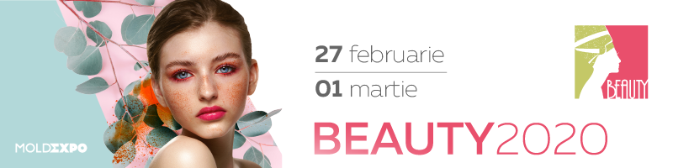
Get charged with energy at BEAUTY 2020!

Between February 27 - March 1, visitors, with the active support of the participants in the BEAUTY 2020 exhibition, will be inspired by the new beauty trends and will get charged with the spring energy, they will also get acquainted with the latest innovations and trends in the world of beauty. They will choose cosmetics and get help from specialists in creating and highlighting their image.

The most awaited visitors of the BEAUTY 2020 are the ladies who want to immerse in the world of beauty - it is for them that the most advanced beauty technologies are created. This year's exhibition will fill three exhibition pavilions of the Moldexpo International exhibition centre, where over 150 participants from Moldova, Italy, Romania, Russia, and Ukraine will present everything related to beauty and the art of creating your own unique image.

Beauty 2020 will have a rich accompanying program that will include various master classes, presentations of famous brands and of new technologies in the beauty industry. Presentations will be held at each exhibition stand and discounts will apply.

Professionals of the beauty industry and general visitors to the BEAUTY 2020 will be able to test, compare and buy cosmetics (as well as tools and equipment), professional skin and body care products, decorative cosmetics, makeup and accessories; they will be able to learn a lot about new services in the field of nail modeling, professional equipment and accessories for hairdressers (including cosmetics for hair care); and last but not least, they will be able to choose professional appliances and furniture for beauty salons.

What will you find at BEAUTY 2020?

The companies S.C. Belar-Grup, Holy Land Cosmetics, Ghizela S.R.L. Cosmotrade S.R.L. and others will help you choose the right professional cosmetics, and the specialists of Vizaje-Nica S.R.L., Bellevie S.R.L., Medix S.R.L., S.C. Tapio BLU S.R.L., Beauty For Life S.R.L., Nyx Cosmetic and others will share useful tips on using make-up to create stunning visual effects.

You will find everything about new trends and solutions in nail design and modeling for 2020 at the stands of E.Mi School SRL, Svitol Art SRL, Golub Stil SRL, Beauty Lux Grup SRL, Inart Studio SRL, Nail Studio SRL, Rio.md and others.

To put the accent on eyelashes is a fairly simple procedure, but it highlights the beauty of the eyes. Companies Lollo & Co SRL, S.R.L. Beauty Lashes, Dream Lashes and others will provide tips and solutions for lashes extension and lamination in order to achieve a result that exceeds expectations.

You can learn how to ensure lasting effects of hair removal and make this procedure less traumatic at the stands of Tarragona S.R.L., I.C.S. Simple Use Beauty and many others.

Hair care cosmetics will be offered by Gontal Grup S.R.L., Svitol Art S.R.L. and others.

Viorica-Cosmetic SA, Virim Impex SRL, Felicia, Antos, Armonie SFC, Elgur Grup SRL, Farmacia Familiei, Hipocrates and others will present secrets of face and body skin care, as well as novelties in medical cosmetics.

Medical optics and sunglasses from famous brands will be presented by Felicia and Interoptic SRL.

The program for specialists and not only

As part of the business program of the exhibition, training events, seminars of participating companies, and master classes will be held.

Innovative tools and equipment for creating chic hair, workshops, new products and special offers are waiting for you at the stand of the partner of the exhibition - the company Loial LTD.

Svitol Art S.R.L. will hold a unique master class from the Italian stylist Stefano Pacella. You will be offered new images and trends of hairdressing from the best catwalks in the world, as well as the presentation of the lightest and most productive hair dryer in the world iQ Perfetto from GA.MA Professional (Italy).

The stylists of Daria Room, the beauty partner of the exhibition, will tell you how to maintain a young and healthy skin, while Medazur will hold the 2nd International Congress of Podologists with the theme “Cooperation of doctors and podologists in solving joint problems in foot and nail diseases” exclusively for specialists in pedicure.

Optiplaza, the style partner of the exhibition, will present 15 world brands of medical optics and sunglasses. Visitors to the company's booth will receive discount cards and gift certificates; they will also be able to get a free consultation of an ophthalmologist.

Meet the spring with freckles at Beauty 2020
If you are the happy owner of freckles, then this promotion is for you! Draw freckles, take a friend, visit the exhibition, take a photo or Stories at the photo zone “Freckles are in fashion now”, mark the pages of the Beauty exhibition (IG & FB - @beautyexhibition), as well as #beyourself, show Stories or your post at the reception and take advantage of a free visit to the exhibition for all 4 DAYS!
And most importantly - pre-registration on the exhibition website www.beautyexpo.moldexpo.md will allow you to get a free invitation ticket for all 4 days of BEAUTY 2020 and benefit from discounts and special offers of participating companies.
Let's meet the spring together at Moldexpo and the result will not be long in coming!
Information partners of the exhibition:
Aquarelle, Agora.md, Ea.md, Estetica, Beauty Formula, MirNevest, BeautyClub.md, Allbeauty.md

