Application form for participation in the exhibition under № __ dated „___”___________20__

Company name:
Index, address: |  |  |  |  |  |  |  |  | Phone:
Legal address: |  |  |  |  |  |  |  |  | Fax
 |  |  |  |  |  |  |  |  | E-mail:
Denomination |  |  |  |  |  |  |  |  | Price(VAT including) |  |  | Quantity |  |  |  | Total (VAT including)
Registration fee |  |  |  |  |  |  |  |  | 130 Euro
Equipped indoor area per 1 m2 |  |  |  |  |  |  |  |  | 120 Euro
Unequipped indoor area per 1 m2 |  |  |  |  |  |  |  |  | 90 Euro
Outdoor exhibition area per 1 m2 |  |  |  |  |  |  |  |  | 50 Euro
Total:
Stand’s type
A Standard □  (1 side open)  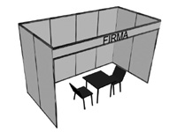 |  |  |  | B Corner □  +10 %  (2 sides open)  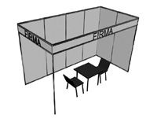 |  |  |  | C Head □  +15%  (3 sides open)  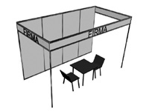 |  |  |  |  |  | D Built apart □  +20%  ( 4 sides open)  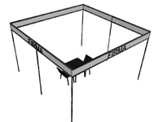
Inscription on fascia board

Attention: Exhibition area is considered reserved just after 30% advance payment out of the cost of the total area reserved, as well as after 100% payment settlement of registration“Participant” fills out the Application form and sends to “Organizer”. After the ordered exhibition area is agreed, “Participant” sends signed Agreement and settles payment for participation

Exhibitor  Director ________________/____________________/  Stamp  Date ___/ ____/ 20__ | Organizer  Commercial Director_______________/  Nadejda Rațeeva/  Stamp  Date ___/ ____/ 20__

IEC "MOLDEXPO" JSC
E-mail: alina.covas@moldexpo.md

