
…………………………………………………………….................................30.10 – 02.11.2025

APPLICATION FORM FOR PARTICIPATION IN THE EXHIBITION under №__ dated “___”_________20__
Company name:
Index, address: |  |  |  |  |  |  |  |  | Phone:
Legal address: |  |  |  |  |  |  |  |  | Fax
 |  |  |  |  |  |  |  |  | E-mail:
Denomination |  |  |  |  |  |  |  |  |  | Price  (VAT including) |  |  |  | Quantity |  |  | Total  (VAT including)
Registration fee |  |  |  |  |  |  |  |  |  | 130 euro
Equipped indoor area per 1m2 |  |  |  |  |  |  |  |  |  | 120 euro
Unequipped indoor area per 1m2 |  |  |  |  |  |  |  |  |  | 90 euro
Advertising in the official catalogue
Additional services
Extra-charges for the stand’s type
Total
STAND’s TYPE
A Standard □  (1 side open)  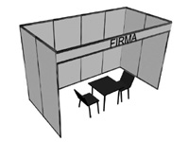 |  |  |  | B Corner □  +10 %  (2 sides open)  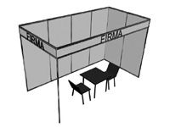 |  |  |  | C Head □  +15%  (3 sides open)  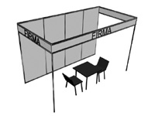 |  |  |  |  |  |  | D Built apart □  +20%  (4 sides open)  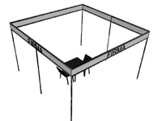
Inscription on fascia board

Attention: Exhibition area is considered reserved just after 30% advance payment out of the cost of the total area reserved, as well as after 100% payment settlement of registration fee.

“Participant” fills out the Application form and sends to “Organizer”. After the ordered exhibition area is agreed, “Participant” sends Agreement signed and settles payment for participation in the exhibition.

EXHIBITOR  Director_____________/................................../  signature  Stamp  Date ___/_____/20__ | ORGANIZER  Interim General Director I.E.C "MOLDEXPO" S.A  _____________/ Zinaida Popa /  Stamp  Date ___/_____/20__

C.I.E. "MOLDEXPO" SA
E-mail: olesea.nicorean@moldexpo.md
E-mail: natalia.shalaru@moldexpo.md

